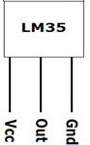
LM35 Temperature Sensor

Power Stabilizing Unit
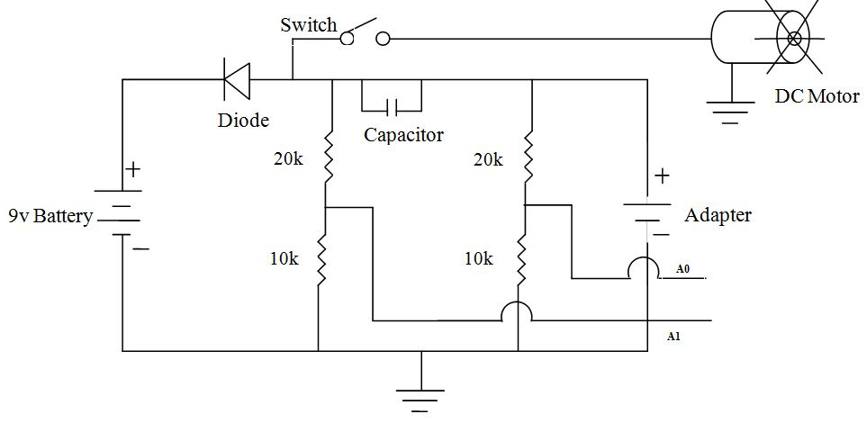 |  | 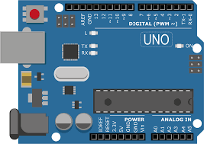  ARDUINO UNO
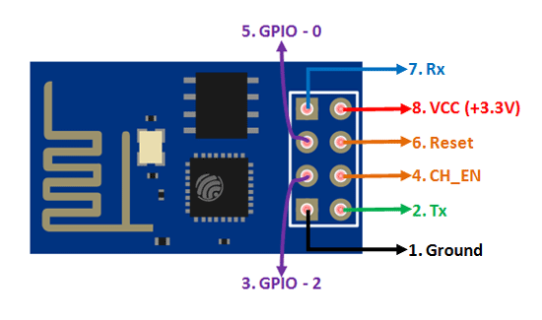  WIFI MODULE (ESP8266) | 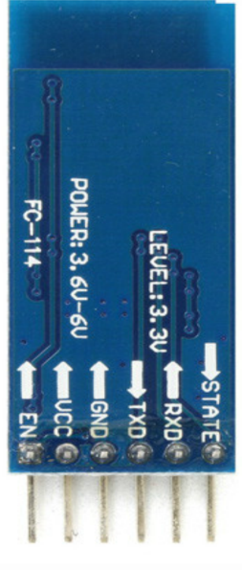  BLUETOOTH MODULE (HC-05)

